5C. NIH Fellowship Applications – Using the NIH Instructions

Figure 5.1

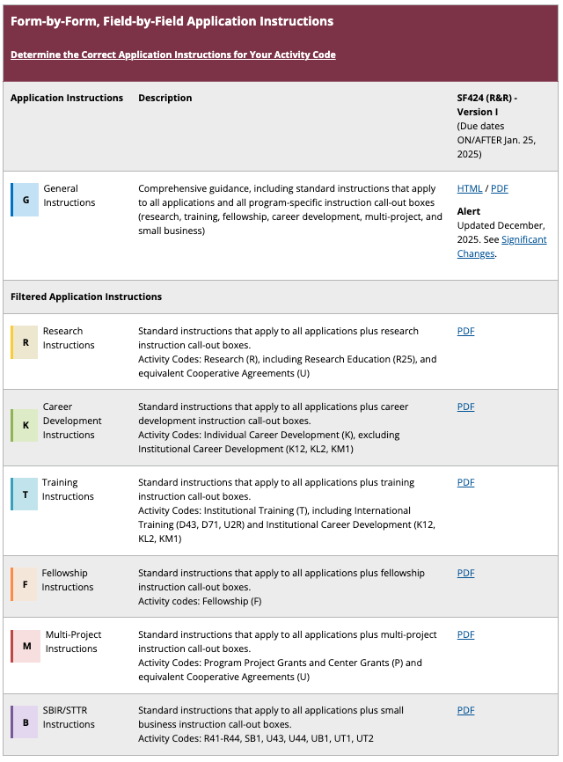

Figure 5.1. Screenshot of the NIH website where you can find the SF424 Application guide that’s relevant to the NIH mechanism you will apply for.

Figure 5.2
Figure 5.2. SF424 (R&R) Form. Forms included in the SF424 guidelines include both fields requiring administrative information and attachments (bottom of page 2 of the form).

Figure 5.3

Figure 5.3. Application component that is uploaded via the SF424 (R&R) Form. The blue arrow identifies the component described in this manual.

Figure 5.4

Figure 5.4. Application components that are uploaded via the SF424 (R&R) Other Project Information Form. The blue arrows identify the components described in this manual.

Figure 5.5

Figure 5.5. Application components that are uploaded via the SF424 (R&R) Project/Performance Site Location(s) Form.

Figure 5.6

Figure 5.6. Application components that are uploaded via the SF424 (R&R) Senior/Key Person Profile Form. The blue arrow identifies the instructions for writing a Biographical Sketch (Biosketch). These instructions are summarized here and in templates and lectures from the SERCC.

Figure 5.7. Application components that are uploaded via the SF424 (R&R) PHS Fellowship Supplemental Form. The blue arrows identify the instructions for writing the components described in this manual. These instructions are summarized in Section 5.4 and are further explained in templates and lectures from the SERCC.
Figure 5.7

